外文翻译及原文
译文

海上监视中的复杂事件识别

摘要
本硕士论文的主要范围是分析和设计用于海上监视目的的复杂事件识别的创新技术解决方案，完全基于Kostas Patroumpas, Alexander Artikis, Nikos Katzouris, Marios Vodas, Yannis Theodoridis和Nikos Pelekis在AMINESS项目背景下提出的论文“海上监视事件识别”中的方法。硕士论文旨在解决使用Apache Flink实时处理和分析可用AIS数据集的挑战。Apache Flink是Apache软件基金会提供的一个实时高性能和精确的自然流处理引擎。最终目标是激励海事当局发展他们的数字文化，并为他们的ICT部门提供新的大数据创新工具，以智能的方式使用现有文件的算法和语义，从而在爱琴海检测船只的轨迹，同时进行准确的复杂事件识别。复杂事件的技术方法和有效推理完全基于RTEC的业务逻辑和事件演算形式语言语义。我们将把这些语义映射到Apache Flink DataStream和Dataset API中，并创建一个有效的替代技术方法。

实现

4. 轨迹检测模块
轨迹检测模块是当前实现的主要部分。我们将通过使用Apache Flink 的DataStream API和Apache Kafka从Kafka主题中连续读取AIS数据来设计一个实时应用程序。我们将集成Apache Flink和Apache Kafka，因为它帮助我们解决了直接从给定静态文件读取数据时由于反压而导致的低吞吐量问题。我们创建了一个Kafka主题，其中包含所有AIS数据集，并为Apache Flink提供数据，以此来完全地模拟实时操作。

4.1 AISEvents类
原始输入元素首先会被建模成AISEvents类。AISEvents类设计为具有以下字段和方法：
变量 | 方法
long previousTS;  long timestamp;  int id;  double lat;  double lon;  double instantSpeed;  public Velocity velocity;  boolean isNoisy;  boolean isPause;  boolean isTurn;  boolean isSpeedChange;  boolean isGapStart;  boolean isGapEnd; | double computeDistance(AisEvent  other)  double computeSpeed(AisEvent  previous)  double computeBearing(AisEvent  previous)
这些字段的值在管道的第一个预处理部分中逐步被定义和计算。从原始AIS数据中，我们使用Apache Flink DataStream API创建“船舶标记事件”的数据流来对无限数据流应用计算。为了将输入的AIS数据建模到AISEvents java类中，我们使用InputParseOperator对其进行扁平映射，该运算符将测量的行作为输入，并将其映射到AISEvents对象，以便分配船舶id、船舶纬度、船舶经度和船舶时间戳，即AIS事件发生的事件时间。事件已被排好序，因此我们不必处理低延迟问题和无序事件。我们使用递增时间戳提取器来定义时间戳和水位线策略。

4.2键控流
管道中的一个关键步骤是检测AIS事件的“间隔开始”和“间隔末尾”，如论文中所述：以便在下一次计算中包括它们。该处理步骤分别针对每个船舶进行。我们使用DataStream Apache Flink API和按键分区算子从逻辑上分离船舶，该算子选择船舶id作为键。这样后续的算子将分别应用于每个船舶。使用这个算子，我们只需从AISEvents对象中提取出船舶id，以便基于它实现逻辑键控流。

4.3会话窗口策略
我们使用了一个配置有会话间隔的会话窗口分配器，它定义了所需的非活动时间。

4.4触发策略
我们使用EventTimeTrigger，它根据水位线测量的事件时间进度触发窗口。这允许增量计算和清除会话窗口。

4.5窗口处理策略
一个窗口函数用于逐个处理属于同一窗口的事件，该窗口将根据触发策略触发并准备好进行处理。对于这个范围，我们实现了SimpleGapOperator算子，它继承了内置的WindowFunction（ProcessWindowFunction）的功能，并实现窗口处理策略。SimpleGapOperator将一个会话窗口中的所有事件存储在一个缓冲区内，以便循环并将窗口的第一个元素定义为“间隔末尾”，最后一个元素定义“间隔开始”。我们会在处理会话窗口的后续算子中设置布尔属性isGapStart和isGapEnd。

4.6计算坐标
轨迹运动事件（如船舶暂停事件或船舶变速事件）和噪声过滤规则取决于船舶的速度矢量和船舶的加速度。为了便于计算速度、方位和距离，我们在MapFunction中使用CoordinatesOperator算子为每个AISEvents分配其对应的笛卡尔坐标。CoordinatesOperator算子分别地应用于AISEvents，因此我们可以提取并分配（x，y，z）坐标给所有的AISEvents，以此来标识它们在地图上的点。为此，不用单独处理每个船舶。这就是我们不使用keyBy算子来按船舶id分组的原因。

4.7短期事件-噪声过滤处理

4.7.1状态
为了能够计算短期事件，我们需要访问同一艘船的先前状态。换句话说，我们需要保持一个包含先前AisEvent取值的状态，并实时正确更新状态。Apache Flink DataStream API提供了有状态的算子，可以通过键来限定范围，即分别为每个船舶保持一个状态。keyBy算子在NoiseOperator算子之前使用，以便根据船舶id对流进行分组。

4.7.2噪声算子
算子实现了海事规则，正如他们在论文:“如何不淹没在信息的海洋中:一种事件识别方法”中所介绍的，以便使用Apache Flink API检测和识别短期事件和噪声事件，为了只保留管道中的关键瞬时信息，并压缩船舶的轨迹。

4.7.2.1功能
如果当前AisEvent是GapEnd的，它可能是间隔之后的第一个AisEvent，我们无法定义其速度、加速度或方位差和速度差，因为我们没有其先前的状态。另外，如果当前AisEvent不是GapEnd的，那么我们就有一个先前的状态，我们可以通过Flink state API检索先前的AisEvent状态。在相同的逻辑中，我们使用computeSpeed函数获取其先前的速度。我们计算一个AISEvent速度的方法是在AISEvent类中实现的，如果它不是GapEnd的，则是与上一个事件的距离，除以当前和上一个AISEvent时间戳之间的差。如果没有上一个的事件，则速度是未定义的。方位同理。我们在AISEvent类中计算上一个AISEvent的方位。我们使用速度和方向属性定义它的速度向量。基于角度和速度属性的Velocity类的实现也是AISEvent类的一部分，并在AISEvent类中实现。为了拿到船舶的瞬时加速度，我们必须将速度差除以同一AISEvent中的当前时间戳和先前时间戳之间的差。因此，如果AISEvent先前状态的速度不为空，我们计算
a）方位差
b）速度差
c）加速度
在任何其他情况下，如果速度为空，我们将前面的所有属性设置为不适用。

在完成前面所有的计算之后，我们将应用论文“如何不淹没在信息的海洋:一种事件识别方法”中提出的船舶轨迹上关键点的规则，来检测船舶轨迹上的停止、加速、转向等关键运动事件。

4.8 {暂停, 变速, 转向} 事件
根据AISEvent类中的计算，我们继续分析瞬时船舶暂停、船舶速度变化和船舶转向，并使用Apache Flink数据流API识别它们。

4.8.1暂停事件–速度变化事件–转向点事件–噪声事件
以下是将物体描述为正在移动状态的最小速度（=1 KNOT），速度以km/h为单位。如果船舶速度值小于1.852 Km/h，则我们将AISEvent识别为暂停事件。如果船舶的速度差大于0.25 KNOTS，则此船舶被认为速度变化，我们将其识别为变速AISEvent。如果连续位置之间的最大航向差超过15度，这表明船舶正在改变其航线方向，因此我们认为这是一个转向点AISEvent。如论文“如何不淹没在信息海洋中：一种事件识别方法”所述，轨迹检测模块必须将数据流压缩为仅包含关键运动AISEvents的流。以下规则用于定义噪声事件并将其从管道中排除。

a） 如果速度变化AISEvent过程中的最大加速度大于10个测量单位，我们将该AISEvent视为噪声事件，因为该速率在实际情况下不可能发生，可能是由例如公海的大浪或AIS信号延迟引起的。接收到的位置被视为异常值，我们将其识别为噪声AISEvent。

b） 如果连续位置之间船舶航向的最大差异（以度为单位）大于60度，则AISEvent被视为噪声事件。同样，这是因为这种速率在实际情况下不可能发生，并且可能是由公海的大浪或AIS信号延迟引起的。接收到的位置被视为异常值，我们将其识别为噪声AISEvent。

c） 如果以km/h为单位的速度为55.56测量单位（=30 KNOT），我们将AISEvent视为噪声事件，因为这在实际情况下也不可能发生。接收到的位置被视为异常值，我们将其识别为噪声AISEvent。

将所有先前的规则应用于数据流，我们依次逐个处理下一个传入的AISEvent，这意味着当前的AISEvent将成为下一个的前一个AISEvent。因此，在进行flatmap(new NoiseOperator())操作之后，我们能够逐个收集所有剩余非噪声事件或间隔的AISEvents：

该处理的结果是JSON格式的仅标记-修改-瞬时AISEvents的可识别流。

6 Kibana可视化

Flink有一个集成的ElasticSearch接收器，它可以帮助将AISEvents发送到ElasticSearch并实时可视化它们。首先，我们必须创建一个将要包含事件的ElasticSearch索引。然后应该指定字段类型，以便能够在地图或地理数据中可视化地理点，或在时间序列中按时间范围查询数据。在本例中，我们为创建的ElasticSearch索引指定以下映射:
curl -XPUT 'localhost:9200/aisevents/_mapping/all?pretty' -H 'Content-Type: application/json' -d
'{
"properties": {
"location": {
"type": "geo_point"
},
"timestamp": {
"type": "date"
}
}
}'

然后我们启动另一个Flink管道，该管道读取原始的AISEvents，将它们预处理为json对象以供ElasticSearch识别，并将它们发送到ElasticSearch索引。

Flink Job有两个操作符:
第一个读取输入的每一行，并将其转换为一个具有以下模式的json:
{timestamp, id, location: {long, lat}}。这是使用Flink 中的MapFunction实现的，如下所示:
.map(new MapFunction<String, Tuple2<String, JsonObject>>() {
@Override
public Tuple2<String, JsonObject> map (String s) throws Exception {
String [] data = s.split(" ");
JsonObject jsonObject = new JsonObject();
jsonObject.addProperty("timestamp", 1000*Long.parseLong(data[0]));
jsonObject.addProperty("id",data[1]);
JsonObject location = new JsonObject();
location.addProperty("lon", Double.parseDouble(data[2]));
location.addProperty("lat", Double.parseDouble(data[3]));
jsonObject.add("location", location);
return Tuple2.of(data[1], jsonObject);
}
})

第二个是ElasticSearch接收器，它将作为结果的json对象发送到指定的ElasticSearch索引(在我们的例子中是“aisevents”):
stream.addSink(new ElasticsearchSink<>(config, transportAddresses,
new ElasticsearchSinkFunction<Tuple2<String, String>>() {
public Index Request createIndexRequest (Tuple2<String, String> element)
{
return Requests.indexRequest()
.index("aisevents")
.type("all")
.source(element.f1);
}
@Override
public void process (Tuple2<String, String> element,Runtime Context ctx,
RequestIndexer indexer) {
indexer.add(createIndexRequest(element));
}
}));

这将导致事件在图[2]中发送后立即被索引并显示在Kibana中：
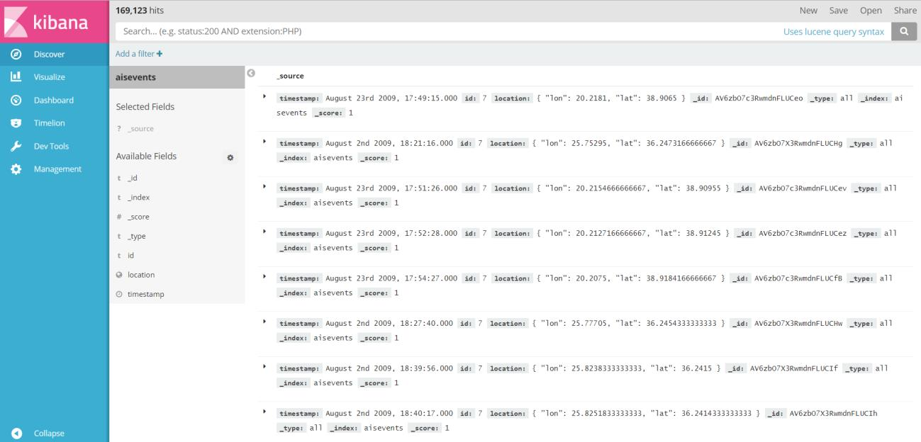
图 [2] : Kibana索引

然后可以使用Kibana集成坐标地图轻松地可视化轨迹，如下图[3]所示:
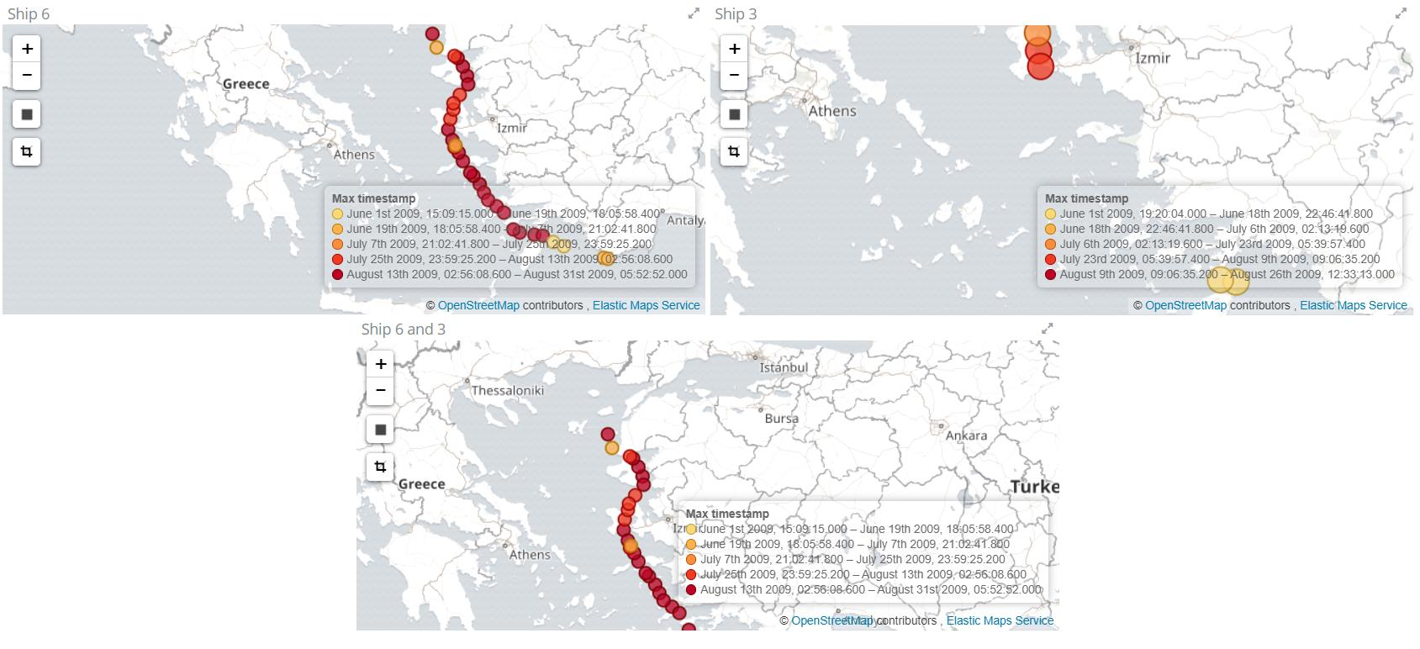
图[3]: 罗德岛附近的船舶轨迹可视化

使用坐标图可视化，我们可以直观地检查复杂事件，例如会合。在下图[3.1]中，我们可以看到“3号船”在6月1日18时至22时在罗兹岛附近：
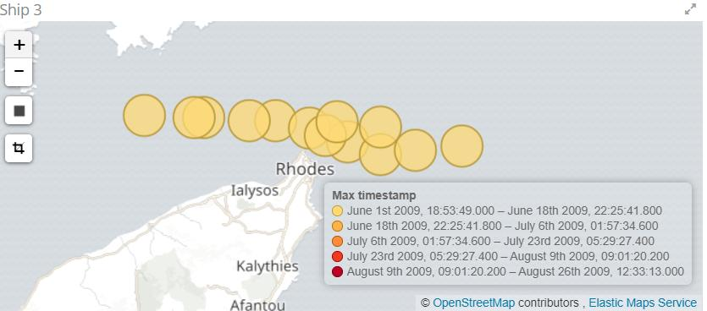
图 [3.1]: 罗德岛附近的船舶轨迹可视化
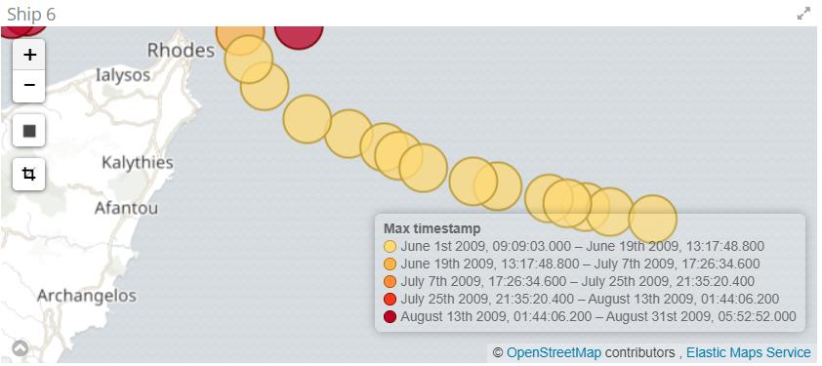
图 [3.2]: 罗德岛附近的船舶轨迹可视化

“6号船”大约在同一时间出现在同一区域，这表明可能的交会被复杂事件识别模块成功识别，如图[3.2]所示。

7建议和下一步行动

- 拟议的服务可被视为处理海上事件的概念证明，目前还远未准备就绪。为了使其适合生产，整个管道应以Kafka为数据源，同时考虑到数据的流性质，也应将其作为数据汇，整个过程应自动化并进行测试，输入和输出都应该正确配置，并可能集成到数据库中。

- 我们实现的一个缺点是在速度变化事件和所有其他事件之间执行代价昂贵的连接以检测快速接近。这点可以优化。

- 另一个改进方向是噪声事件的自动检测，目前使用硬连线规则执行，并且可以使用机器学习技术来预测船舶轨迹并将噪声事件过滤为异常值。

- 另一个改进可能是考虑对复杂事件识别模块中使用的算法进行流适配，由于流API的限制，目前使用批处理API执行该模块。

- 使用流数据编写大数据程序（如MapReduce函数）的开发人员可以采用任何格式的数据，连接不同的集合，将其简化为键值对（map），然后在相邻的对上运行计算以产生一些最终计算值。他们还可以将这些数据项插入到机器学习算法中，以进行一些预测（预测模型）或发现模式（分类模型）。

原文

来源：
Καραγεώργος, Λ. (2017). Complex event recognition for Maritime Surveillance (Doctoral dissertation, University of Piraeus (Greece)).

Complex Event Recognition for Maritime Surveillance

ABSTRACT
The main scope of this Master thesis is to analyze and design an innovative technological solution for Complex Event Recognition for Maritime Surveillance purposes, based entirely on the approach presented in the Paper “Event Recognition for Maritime Surveillance” by Kostas Patroumpas, Alexander Artikis, Nikos Katzouris, Marios Vodas, Yannis Theodoridis and Nikos Pelekis in the context of the AMINESS project. The master Thesis aims to tackle the challenge of processing and analyzing the available AIS Data sets in real time using Apache Flink. Apache Flink is a real time high-performance and accurate natural Stream Processing Engine from Apache Software Foundation. The ultimate goal is to inspire Maritime authorities to develop their digital culture and empower their ICT departments with a new big data innovative tool that uses the existing Paper’s algorithms and semantics in an intelligent way, so as to detect vessel’s Trajectories in the Aegean Sea while performing accurate Complex Event Recognition. The technical approach and the effective reasoning of complex events is totally based on the business logic of RTEC and the Event Calculus formal language semantics. We are going to map these semantics into Apache Flink DataStream and Dataset API and create an efficient alternative technical approach.

IMPLEMENTATION

4. Trajectory Detection Module
The Trajectory Detection Module is the main part of the current implementation. We are going to design a real time application by continuously read AIS data from a Kafka topic using Apache Flink DataStream API and Apache Kafka. We integrate Apache Flink with Apache Kafka because it solved us the low throughput issues due to backpressure while reading directly the data from the given static file. We created a Kafka topic from which contains all the AIS data set and we feed Apache Flink, fully simulating its operations in real time.

4.1 AISEvents class
The raw input elements are first modeled into an AISEvents class. An AISEvents class is designed to have the following fields and methods:
Fields | Methods
long previousTS;  long timestamp;  int id;  double lat;  double lon;  double instantSpeed;  public Velocity velocity;  boolean isNoisy;  boolean isPause;  boolean isTurn;  boolean isSpeedChange;  boolean isGapStart;  boolean isGapEnd; | double computeDistance(AisEvent  other)  double computeSpeed(AisEvent  previous)  double computeBearing(AisEvent  previous)

The values of those fields are defined and computed progressively in the first, preprocessing, part of the pipeline. From raw AIS data, we create Data Streams of “Vessel Tagged Events” using Apache Flink DataStream API in order to apply computations over infinite data streams. So as to model input AIS data into an AISEvents java class we flatmap them with the InputParseOperator which takes as input the measurement lines and maps them to AISEvents objects so as to assign the vessel id, vessel latitude, vessel longitude and vessel timestamp which is the event time the AIS event happened. Events are already ordered, so we don't have to handle low latency issues and out of order events. We are using the ascending timestamp extractor to define timestamps and watermark policy.

4.2 Keyed Streams
A critical step in the pipeline is to detect the “Gaps Starts” and “Gap Ends” of the AIS Events as it is presented in the Paper: so as to include them in next calculations. This processing step is done for each vessel separately. We separate logically the vessels using DataStream Apache Flink API and the key by operator which selects the id of the vessel as the key. This way the subsequent operator is applied to each vessel separately. With this operator, we simply extract the vessel’s id, from an AISEvents object, so as to implement logical keyed streams based on the vessel’s id.

4.3 Session windowing policy
We used a session window assigner configured with session gap which defines how long is the required period of inactivity.

4.4 Triggering policy
We used EventTimeTrigger, that triggers the window based on the progress of event time as measured by the watermarks. This permits an incremental computation and purging of the session windows.

4.5 Window Process Policy
A Windowing function is used to process one by one the events that belong to the same window which fires and becomes ready for processing based on the triggering policy. For this scope, we implemented the SimpleGapOperator Operator which extends the functionality of the built-in WindowFunction (ProcessWindowFunction) and implements the window processing policy. The SimpleGapOperator stores all the events of a session window inside a buffer in order to loop and define the first element of the window as the “Gap End” and the last one “Gap Start”. We set boolean attributes isGapStart, isGapEnd in the subsequent operator which processes the session windows.

4.6 Computing Coordinates
Trajectory Movement Events like vessel Pause Events or vessel Speed Change Events, as well as Noise Filtering rules depends on the vessel’s velocity vector and the vessel’s acceleration. To facilitate computing the speed, bearing and distances, we use the MapFunction to assign each AISEvents its Cartesian coordinates using the Coordinates Operator Operator. The CoordinatesOperator Operator is applied to AISEvents one by one so we can extract and assign (x,y,z) coordinates to all AISEvents to indicate their points on the map. For this purpose, it is no need to treat each vessel separately. That’s why we do not use the keyby operator so as to group by vessel’s id’s.

4.7 Short Term Events - Noise Filtering Process

4.7.1 State
To be able to compute Short-term Events we need to access the previous state of the same vessel. In other words, we need to keep a state which contains previous AisEvent values and to update correctly the state in real time. Apache Flink DataStream API offers stateful operators, which can be scoped by key, i.e. keep a state for each vessel separately. Keyby operator is used before the NoiseOperator Operator so as to group the stream by vessel’s id.

4.7.2 NoiseOperator
Operator implements maritime rules, as they introduced in the Paper: “How not to drown in a sea of information: An event recognition approach” so as to detect and recognize with Apache Flink API both Short Term Events and Noise Events in order to keep only the critical instantaneous information in the pipeline and compress the Trajectory of the vessels.

4.7.2.1 Functionality
If the AisEvent is a GapEnd that is the first AISEvent potentially after a gap we cannot define its velocity, acceleration, or Bearing Differences and Speed Differences because we do not have its previous state. Otherwise, if the AisEvent is not a GapEnd - so we have a previous state that we retrieve the previous AISEvent state from Flink State API. In the same logic we fetch its previous speed using the computeSpeed function. The way we compute the Speed of an AISEvent, is implemented inside the AISEvent class and is the distance from the previous event if it is not a GapEnd, divided by the difference between current and previous AISEvent timestamps. If there is no previous event the speed is undefined. The same goes for the bearing. We compute the Bearing of the previous AISEvent inside the AISEvent class. We define its Velocity vector using speed and bearing attributes. The implementation of the Velocity class based on angle and speed attributes is also part and implemented inside the AISEvent class. In order to fetch the
instant acceleration of the vessel, we have to divide Speed Difference from the difference between the current and the previous timestamp of the same AISEvent. So, if the velocity of the previous status of the AISEvent is not null, we compute
a) The Bearing difference
b) The Speed difference

c) The acceleration
In any other case, if the velocity is null, we set all the previous attributes as not applicable.

Having done all the previous calculations, we are about to apply the rules for critical points along vessel trajectories as presented in the paper “How not to drown in a sea of information: An event recognition approach” so as to detect vessel’s critical movement events such as stops, acceleration or turn events along their trajectory.

4.8 {Pause, Speed Change, Turn} Events
Based on the AISEvent class calculations we continue by analyzing instantaneous vessel Pauses, vessel speed changes and vessel turns and recognize them with Apache Flink Datastream API.

4.8.1 Pause Event – Speed Change Event – Turn Point Event – Noise Events
The minimum speed in km/h (=1 KNOT) so as to characterize an object as a moving one is following. If the value of the vessel’s speed is less than 1.852 Km/h then, we recognize the AISEvent as a Pause Event. If the vessel’s Speed difference is more than 0.25 KNOTS, the vessel is supposed to have a speed change and we recognize it as SpeedChange AISEvent. If the maximum heading difference between successive positions is more than 15 degrees, this suggests that the vessel is changing its route direction, so we recognize that this is a Turn Point AISEvent. As presented in the paper: “How not to drown in a sea of information: An event recognition approach”, the Trajectory Detection Module has to compress the Data Stream into a stream that contains only critical movement AISEvents. The following rules are used so as to define noise events and to exclude them from the pipeline.

a) If the maximum acceleration during a speed change AISEvent is greater than 10 measurement units, we consider this AISEvent a noise event, because this rate cannot happen in real conditions and may have been caused for example by high waves in the open sea or by AIS signal delays. The received position is considered an outlier and we recognize it as a Noise AISEvent.

b) If the maximum difference in vessel’s heading between successive positions (in degrees) is greater than 60 degrees, then the AISEvent is considered as a noise event. Again, this is because this rate cannot happen in real conditions and may have been caused by high waves in the open sea or by AIS signal delays. The received position is considered an outlier and we recognize it as a Nose AISEvent.

c)If the speed in km/h is 55.56 measurement units (=30 KNOTs), we consider the AISEvent as a noise Event, because again this cannot happen in real conditions. The received position is considered an outlier and we recognize it as a Noise AISEvent.

By applying all the previous rules to the DataStream, we process the next incoming AISEvent sequentially and one by one which means that the current AisEvent becomes the previous AisEvent for the next one. So, after the flatmap (new NoiseOperator ()) application, we are able to collect one by one all the rest AISEvents that are not Noise Events or Gaps:

The result of the process, is a recognized stream of only tagged - modified - instantaneous AISEvents in JSON format.

6 Visualizations with Kibana

Flink has an integrated ElasticSearch sink, which helps sending AISEvents to
ElasticSearch and visualizing them in in real-time. One first we have to create an ElasticSearch index which will contain the events. Then one should specify fields types, to be able to visualize geopoints in maps in case or geographical data or to query data by time range in case of time series. In our case, we specify the following mapping for the ElasticSearch index we created:
curl -XPUT 'localhost:9200/aisevents/_mapping/all?pretty' -H 'Content-Type: application/json' -d
'{
"properties": {
"location": {
"type": "geo_point"
},
"timestamp": {
"type": "date"
}
}
}'

Then we launch another Flink pipeline which reads the raw AISEvents, pre-process them into json objects to be recognized by ElasticSearch and send them to ElasticSearch index.

The Flink Job has two operators:

The first one reads each line of the input and converts it to a json with the following schema:
{timestamp, id, location: {long, lat}}. This is achieved using a Flink MapFunction as follows:
.map(new MapFunction<String, Tuple2<String, JsonObject>>() {
@Override
public Tuple2<String, JsonObject> map (String s) throws Exception {
String [] data = s.split(" ");
JsonObject jsonObject = new JsonObject();
jsonObject.addProperty("timestamp", 1000*Long.parseLong(data[0]));
jsonObject.addProperty("id",data[1]);
JsonObject location = new JsonObject();
location.addProperty("lon", Double.parseDouble(data[2]));
location.addProperty("lat", Double.parseDouble(data[3]));
jsonObject.add("location", location);
return Tuple2.of(data[1], jsonObject);
}
})

The second one is the ElasticSearch sink which sends the resulting json objects to the specified ElasticSearch index (“aisevents” in our case):
stream.addSink(new ElasticsearchSink<>(config, transportAddresses,
new ElasticsearchSinkFunction<Tuple2<String, String>>() {
public Index Request createIndexRequest (Tuple2<String, String> element) {
return Requests.indexRequest()
.index("aisevents")
.type("all")
.source(element.f1);
}
@Override
public void process (Tuple2<String, String> element,Runtime Context ctx,
RequestIndexer indexer) {
indexer.add(createIndexRequest(element));
}
}));

This results in the events being indexed and shown in Kibana as soon as they are sent in Figure [2]:
Figure [2] : Kibana indexing

One can then easily visualize trajectories using Kibana integrated Coordinate Maps as described below in Figure [3]:
Figure [3]: Vessel Trajectory Visualization near Rhodes island

Using the coordinates map visualization, we can visually check for complex events like rendezvous for example. In the following Figure [3.1] we can see that the “Ship 3” was around Rhodes in June 1st between 18h and 22h:
Figure [3.1]: Vessel Trajectory Visualization near Rhodes island
Figure [3.2]: Vessel Trajectory Visualization near Rhodes island

And that the “Ship 6” was in the same area around the same time which suggest a possible rendezvous which was successfully recognized by the complex event recognition module, as it is visualized in Figure [3.2]

7 Proposals and next steps

- The proposed service can be considered a proof of concept for treating maritime events and is far from being ready for production. To make it suitable for production, the full pipeline should be set up with Kafka a data source and also as a data sink given the streaming nature of the data, the whole process should be automated and tested, and input and outputs should be properly configured and possibly integrated to databases.

- One shortcoming of our implementation is the costly join performed between speed change events and all other events to detect fast approaches. This can maybe be optimized.

- Another track of improvement is the automated detection of noisy events, which is currently performed using hard wired rules, and could maybe be performed using machine learning techniques to predict vessel trajectories and filter noisy events as outliers.

- Another improvement might be to think of a streaming adaptation of the algorithms used in the complex event recognition module which is currently performed using the batch API due to the streaming API limitations.

- Developers who write big data programs (like MapReduce functions) withstreaming data can take data in whatever format it is in, join different sets, reduce it to key-value pairs (map), and then run calculations on adjacent pairs to produce some final calculated value. They also can plug these data items into machine learning algorithms to make some projection (predictive models) or discover patterns (classification models).

